Chapter 15
Globalizing Web Applications
About This Chapter
Globalization is the process of creating an application that meets the needs of users from multiple cultures. This process involves more than just translating the user interface elements of an application into multiple languages—it also includes using the correct currency, date and time format, calendar, writing direction, sorting rules, and other issues. Accommodating these cultural differences in an application is called localization.
Fortunately, the Microsoft .NET Framework simplifies localization tasks substantially by making its formatting, date/time, sorting, and other classes culturally aware. Using classes from the System.Globalization namespace, you can set your application’s current culture, and much of the work is done for you automatically!
In this chapter, you’ll learn how to detect a user’s culture and create appropriate responses, ranging from redirecting the user to a separate, localized Web application to handing cultural differences within code and displaying a localized user interface.
Before You Begin
To complete this chapter, you must:
- Be familiar with HTML
- Be comfortable creating Web forms in HTML mode
Lesson 1: Choosing an Approach
Before you begin the process of localization, you need to understand the advantages and disadvantages of the different approaches to globalizing Web applications. In this lesson, you’ll learn about three different ways to structure your application for globalization. These approaches are organized from simplest to most complex. The last approach is covered in more detail in Lesson 2.
After this lesson, you will be able to
- Choose a globalization approach that best meets your needs
- Detect and respond to a user’s culture
- Create a culture-specific Web application using settings in Web.config
- Change the culture used within your application to evaluate dates, format currencies, and handle other culture-dependent tasks
- Detect the culture currently in use by the application
- Explain the difference between the CurrentCulture and CurrentUICulture properties
Estimated lesson time: 30 minutes
Ways to Globalize Web Applications
There are several different approaches to creating Web applications that support multiple cultures. Each approach is based on the globalization tools that the .NET Framework provides. Choose a single approach or a combination of approaches based on your applications needs, as described in Table 15-1.
All three of the approaches depend on detecting the user’s culture at run time and then forming a response based on that information. The following sections show in greater detail how to detect the user’s culture and respond by using each of these approaches. These sections also provide more detail on the relative advantages of each approach.
Table 15-1. Globalization Approaches
Approach | Description | Best for
Detect and redirect | Create a separate Web application for each supported culture, and then detect the user’s culture and redirect the request to the appropriate application. | Applications with lots of text content that requires translation and few executable components.
Run-time adjustment | Create a single Web application that detects the user’s culture and adjusts output at run time using format specifiers and other tools. | Simple applications that present limited amounts of content.
Satellite assemblies | Create a single Web application that stores culture-dependent strings in resource files that are compiled into satellite assemblies. At run time, detect the user’s culture and load strings from the appropriate assembly. | Applications that generate content at run time or that have large executable components.
Detecting the User’s Culture
The .NET Framework provides components for supporting multiple cultures and language in the System.Globalization namespace. The CultureInfo, Calendar, and comparison classes that you use throughout this chapter are all part of that namespace. Use the following line to import that namespace so that you can use its classes without qualifying the references:
Visual Basic .NET
Imports System.Globalization
Visual C#
using System.Globalization;
Microsoft ASP.NET uses the Request object’s UserLanguages property to return a list of the user’s language preferences. The first element of the array returned by UserLanguages is the user’s current language. You can use that value to create an instance of the CultureInfo class representing the user’s current culture.
To get the user’s culture at run time, follow these steps:
- Get the Request object’s UserLanguages property.
- Use the returned value with the CultureInfo class to create an object representing the user’s current culture.
For example, the following code gets the user’s culture and displays the English name and the abbreviated name of the culture in a label the first time the page is displayed:
Visual Basic .NET
Private Sub Page_Load(ByVal sender As System.Object, _
ByVal e As System.EventArgs) Handles MyBase.Load
' Run the first time the page is displayed
If Not IsPostBack Then
Dim sLang As String
' Get the user's preferred language.
sLang = Request.UserLanguages(0)
' Create a CultureInfo object from it.
Dim CurrentCulture As New CultureInfo(sLang)
lblCulture.Text = CurrentCulture.EnglishName & ": " & _
CurrentCulture.Name
End If
End Sub
Visual C#
private void Page_Load(object sender, System.EventArgs e)
{
// Run the first time the page is displayed
if (!IsPostBack)
{
// Get the user's preferred language.
string sLang = Request.UserLanguages[0];
// Create a CultureInfo object from it.
CultureInfo CurrentCulture = new CultureInfo(sLang);
lblCulture.Text = CurrentCulture.EnglishName + ": " +
CurrentCulture.Name;
}
}
TIP
The CultureInfo class’s Name property and the Request object’s UserLanguages array values use different capitalization schemes. If you’re comparing the two values, be sure to convert the Name property to lowercase.
Redirecting to Culture-Specific Web Applications
Conceptually, redirecting is the simplest way of dealing with multiple cultures. When a user requests the default page for your application, you detect his or her culture and then redirect the response to the appropriate Web application, as shown in Figure 15-1.
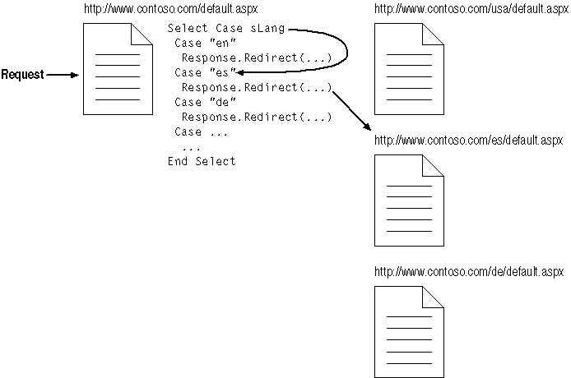
Figure 15-1. Detect and redirect
This approach has some advantages in addition to conceptual simplicity:
- Content is maintained separately, so this approach allows the different applications to present very different information, if needed.
- Users can be automatically directed to sites that are likely to be geographically close, and so can better meet their needs.
- Content files (Web forms and HTML pages, for example) can be authored in the appropriate natural language without the complexity of including resource strings.
Maintaining content separately is best suited for Web applications that present large amounts of content that must be translated or otherwise changed for other cultures. Using this approach requires that the executable portion of the Web application be compiled and deployed separately to each culture-specific Web site. This requires more effort to maintain consistency and to debug problems across Web sites.
Redirecting Based on Primary Language
Both the Request object’s UserLanguages array and the CultureInfo class’s Name property return culture information in two parts: the first two letters are the language code; the last two letters contain a region code. For example, English US (en-US) and English United Kingdom (en-GB) both use English, but they display different currencies and date order.
To redirect requests based on language alone, follow these steps:
- Get the user’s preferred language or CurrentCulture, as shown previously.
- Get the first two letters of the returned value.
- Compare those letters to the list of language codes.
For example, the following code detects the user’s language and then redirects the user to one of several different language-specific Web sites:
Visual Basic .NET
Private Sub Page_Load(ByVal sender As System.Object, _
ByVal e As System.EventArgs) Handles MyBase.Load
Dim sLang As String
' Get the user's preferred language.
sLang = Request.UserLanguages(0)
' Get the first two characters of language.
sLang = sLang.Substring(0, 2)
' Redirect user based on his/her culture.
Select Case sLang
Case "en"
' Use US site.
Response.Redirect("http://www.contoso.com/usa")
Case "es"
' Use Spanish site.
Response.Redirect("http://www.contoso.com/es")
Case "de"
' Use German site.
Response.Redirect("http://www.contoso.com/de")
Case "zh"
' Use Chinese site.
Response.Redirect("http://www.contoso.com/zh")
Case Else
' Use US site.
Response.Redirect("http://www.contoso.com/usa")
End Select
End Sub
Visual C#
private void Page_Load(object sender, System.EventArgs e)
{
// Get the user's preferred language.
string sLang = Request.UserLanguages[0];
// Get the first two characters of language.
sLang = sLang.Substring(0, 2);
// Redirect user based on his/her culture.
switch (sLang)
{
case "en":
// Use US site.
Response.Redirect("http://www.contoso.com/usa");
break;
case "es":
// Use Spanish site.
Response.Redirect("http://www.contoso.com/es");
break;
case "de":
// Use German site.
Response.Redirect("http://www.contoso.com/de");
break;
case "zh":
// Use Chinese site.
Response.Redirect("http://www.contoso.com/zh");
break;
default:
// Use US site.
Response.Redirect("http://www.contoso.com/usa");
break;
}
}
}
See the “CultureInfo Class” topic in the Microsoft Visual Studio .NET online Help for a listing of the language and culture codes.
Setting Culture in Web.config
Use the Web.config file’s globalization element to create a culture-specific Web application. The culture attribute of the globalization element specifies how the Web application deals with various culture-dependent issues, such as dates, currency, and number formatting.
Web.config globalization settings in subordinate folders override the globalization settings in the application’s root Web.config file. You can store content for various cultures in subfolders within your application, add Web.config files with the globalization settings for each culture, then direct users to the appropriate folder based on the user’s CurrentCulture. For example, the following Web.config entry handles the Web application’s requests and responses using the Arabic (Saudi Arabia) [ar-SA] culture:
<globalization requestEncoding="utf-8" responseEncoding="utf-8"
culture="ar-SA" />
At run time, the Web application displays dates, currency, and number formats according to the culture attribute setting in the Web.config’s globalization element, as shown in Figure 15-2.
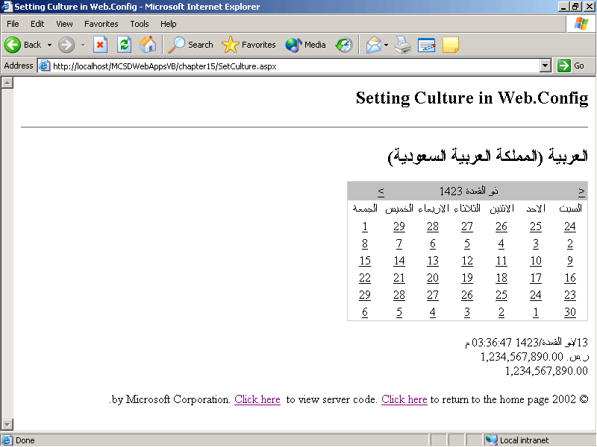
Figure 15-2. A culture-specific response
In Figure 15-2, the dates, times, numbers, and currencies are displayed using the Arabic (Saudi Arabia) settings. However, the entire page is not displayed in right-to-left formatting, as you might expect for Arabic. To display the page correctly, you must set the HTML dir attribute for the page’s body element, as shown here:
<body dir="rtl">
You can use the dir attribute individually in panels, text boxes, or other controls as well. Setting the dir attribute on the body element applies right-to-left formatting to the entire page, as shown in Figure 15-3.
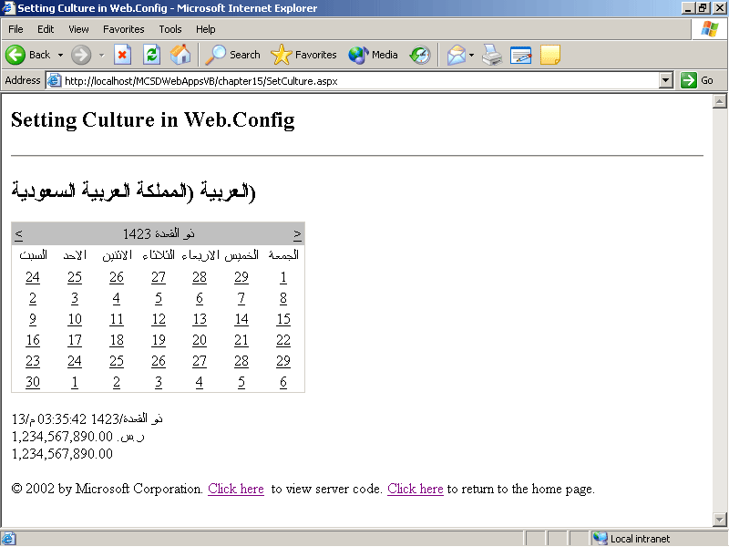
Figure 15-3. Right-to-left formatting
Adjusting to Current Culture at Run Time
By default, Web applications run on the server using a neutral culture. Neutral cultures represent general languages, such as English or Spanish, rather than a specific language and region. When you set the culture attribute for a Web application in Web.config, ASP.NET assigns that culture to all the threads running for that Web application. Threads are the basic unit to which the server allocates processor time—ASP.NET maintains multiple threads for a Web application within the aspnet_wp.exe worker process.
Using Web.config to set the culture creates a static association between the application and a specific culture. Alternatively, you can set the culture dynamically at run time using the Thread class’s CurrentCulture property, as shown here:
Visual Basic .NET
Imports System.Globalization
Imports System.Threading

Private Sub Page_Load(ByVal sender As System.Object, _
ByVal e As System.EventArgs) Handles MyBase.Load
Dim sLang As String
' Get the user's preferred language.
sLang = Request.UserLanguages(0)
' Set the thread's culture to match the user culture.
Thread.CurrentThread.CurrentCulture = New CultureInfo(sLang)
End Sub
Visual C#
using System.Globalization;
using System.Threading;

private void Page_Load(object sender, System.EventArgs e)
{
// Get the user's preferred language.
sLang = Request.UserLanguages[0];
// Set the thread's culture to match the user culture.
Thread.CurrentThread.CurrentCulture = new CultureInfo(sLang);
}
The preceding code detects the user’s culture and then sets the culture of the current thread to match. ASP.NET will then format date, currency, and numeric strings using the user’s culture.
Setting the culture dynamically at the thread level has the following advantages over creating separate Web applications for each culture:
- All cultures share the same application code, so the application doesn’t have to be compiled and deployed for each culture.
- The application resides at a single Web address—you don’t need to redirect users to other Web applications.
- The user can choose from a full array of available cultures.
Setting the culture dynamically is best suited for simple Web applications that don’t contain large amounts of text that must be translated into different languages. To provide large amounts of translated content through a single Web application, use the technique described in the section “Using Satellite Assemblies,” later in the chapter.
Setting the Current Culture
The following code illustrates the main advantages of setting the culture dynamically at the thread level. The first time the page loads, the code builds a list of all available cultures and stores them in a drop-down list box. When the user chooses a culture from the drop-down list, the code assigns that culture to the current thread, and ASP.NET displays the Web form using the selected culture.
Visual Basic .NET
Imports System.Globalization
Imports System.Threading

Private Sub Page_Load(ByVal sender As System.Object, _
ByVal e As System.EventArgs) Handles MyBase.Load
' Add cultures to drop-down
' list box the first time the page is displayed.
If Not IsPostBack Then
' Create an array of specific cultures.
Dim arrCultures() As CultureInfo = _
CultureInfo.GetCultures(CultureTypes.SpecificCultures)
Dim item As CultureInfo
' For each specific culture
For Each item In arrCultures
' Add the name of the culture as an item in the list box.
drpCulture.Items.Add(New ListItem(item.EnglishName, item.Name))
' If the item is the thread's current culture, select it.
If item.Name = Thread.CurrentThread.CurrentCulture.Name Then
' Select this list item
drpCulture.SelectedIndex = drpCulture.Items.Count - 1
End If
Next
End If
End Sub

Private Sub drpCulture_SelectedIndexChanged(ByVal sender As System.Object, _
ByVal e As System.EventArgs) Handles drpCulture.SelectedIndexChanged
' Change the culture of the current thread to match selection.
Thread.CurrentThread.CurrentCulture = New _
CultureInfo(drpCulture.SelectedItem.Value)
' Get the culture for the selected item.
Dim SelectedCulture As New CultureInfo(drpCulture.SelectedItem.Value)
End Sub

Private Sub Page_PreRender(ByVal sender As Object, _
ByVal e As System.EventArgs) Handles MyBase.PreRender
' Display the culture's native name in the heading.
head1.InnerHtml = Thread.CurrentThread.CurrentCulture.NativeName
' Display Date, Currency, and Numeric strings formatted for the culture.
Label1.Text = DateTime.Now.ToString("F")
Label2.Text = 1234567890.ToString("C")
Label3.Text = 1234567890.ToString("N")
End Sub
Visual C#
using System.Globalization;
using System.Threading;

private void Page_Load(object sender, System.EventArgs e)
{
// Add cultures to drop-down
// list box the first time the page is displayed.
if (!IsPostBack)
{
// Create an array of specific cultures.
CultureInfo[] arrCultures =
CultureInfo.GetCultures(CultureTypes.SpecificCultures);
// For each specific culture
foreach (CultureInfo item in arrCultures)
{
// Add the name of the culture as an item in the list box.
drpCulture.Items.Add(new ListItem(item.EnglishName,
item.Name));
// If the item is the thread's current culture, select it.
if (item.Name == Thread.CurrentThread.CurrentCulture.Name)
// Select this list item
drpCulture.SelectedIndex = drpCulture.Items.Count - 1;
}
}
}

private void drpCulture_SelectedIndexChanged(object sender,
System.EventArgs e)
{
// Change the culture of the current thread to match selection.
Thread.CurrentThread.CurrentCulture = new
CultureInfo(drpCulture.SelectedItem.Value);
// Get the culture for the selected item.
CultureInfo SelectedCulture = new
CultureInfo(drpCulture.SelectedItem.Value);
}

private void Page_PreRender(object sender, System.EventArgs e)
{
// Display the culture's native name in the heading.
head1.InnerHtml = Thread.CurrentThread.CurrentCulture.NativeName;
// Display Date, Currency, and Numeric strings formatted for the culture.
Label1.Text = DateTime.Now.ToString("F");
Label2.Text = 1234567890.ToString("C");
Label3.Text = 1234567890.ToString("N");
}
The preceding code sets the heading and label text in the PreRender event so that the culture change takes place before the text is stored in those controls. The ToString method uses format specifiers to format each string according to the current culture. For more information about format specifiers, see the “Formatting Types” topic in the Visual Studio .NET online Help. Figure 15-4 shows the preceding code in action on a Web form.
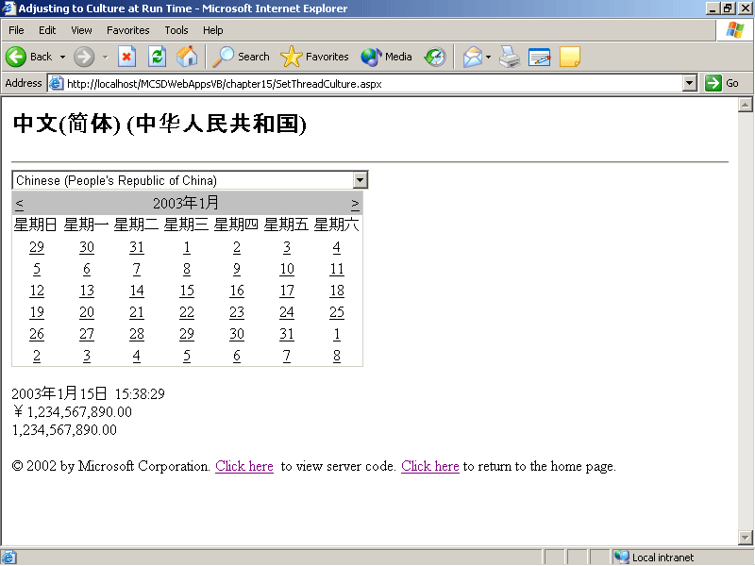
Figure 15-4. Setting the culture at the thread level
When the user selects a new culture from the drop-down list in Figure 15-4, the heading, calendar, date, currency, and numeric strings are translated automatically.
Responding to the Thread’s Culture
You can also get the culture that a Web application is running under by using the thread’s CurrentCulture property. For example, the following code displays a panel on a Web form using right-to-left formatting if the current culture is Arabic or Hebrew:
Visual Basic .NET
Private Sub Page_Load(ByVal sender As System.Object, _
ByVal e As System.EventArgs) Handles MyBase.Load
' Get culture of current thread.
Dim CurrentCulture As CultureInfo = Thread.CurrentThread.CurrentCulture
' Get the primary language.
Dim sLang As String = CurrentCulture.Name.Substring(0, 2)
' If it's Arabic or Hebrew, display right-to-left.
If sLang = "ar" or sLang = "he" Then
panel1.Attributes.Add("dir", "rtl")
End If
End Sub
Visual C#
private void Page_Load(object sender, System.EventArgs e)
{
// Get culture of current thread.
CultureInfo CurrentCulture = Thread.CurrentThread.CurrentCulture;
// If culture is Arabic or Hebrew, use right-to-left layout.
string sLang = CurrentCulture.Name.Substring(0, 2);
if ((sLang == "ar") ││(sLang == "he"))
{
Panel1.Attributes.Add("dir", "rtl");
}
}
Using Satellite Assemblies
The preceding section showed you how to handle cultural differences within a single Web application, but it omitted one important detail: how do you handle translated content? That’s a job for satellite assemblies.
Satellite assemblies allow you to store the translated strings for each culture in a separate, resource-only assembly file that you can load automatically based on the setting of the CurrentUICulture property. Using satellite assemblies provides the same advantages as adjusting to the culture at run time, plus satellite assemblies simplify displaying content from multiple translated sources. The next lesson describes how to create and use satellite assemblies in detail.
Lesson 2: Creating and Using Satellite Assemblies
Satellite assemblies are assembly files (.dll) that contain localized resources for an application. Each satellite assembly file contains the resources for one culture. An application can have many satellite assemblies, depending on how many cultures the application supports.
In this lesson, you’ll learn how to prepare a Web application to use satellite assemblies, how to store localized user-interface elements within a satellite assembly, and how to load and display elements from the satellite assembly at run time.
After this lesson, you will be able to
- Create localized resources and add them to satellite assemblies
- Enable HTML elements within your application to display localized strings from satellite assemblies
- Load resources into a ResourceManager object
- Understand how ASP.NET selects the resources to load based on the CurrentUICulture property
- Get strings from the ResourceManager object and display them in the user interface
Estimated lesson time: 30 minutes
How Satellite Assemblies Work
Web application projects use satellite assemblies to store the translated strings, graphics, and other culture-dependent aspects of an application’s user interface. To create the assemblies themselves, you use the Resource Manager. At run time, the Web application loads the translated strings into the Web form based on the current thread’s CurrentUICulture property, as shown in Figure 15-5.
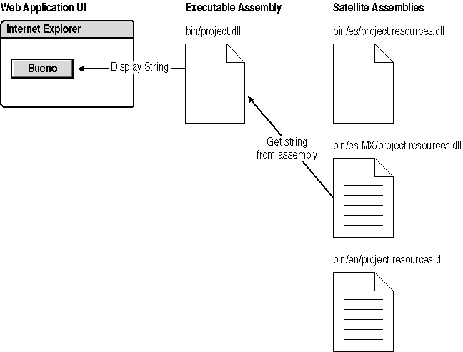
Figure 15-5. Satellite assemblies at work
To use satellite assemblies, follow these steps:
- Set the id and runat attributes for all of the user-interface elements of your application that require translation. Server controls have these attributes by default, but you will need to add them to HTML elements such as heading, paragraph, and span so that you can load translated strings into those elements.
- Create a fallback resource file containing the default strings to display in the user interface if the user’s culture is not specified or not recognized. Name the fallback resource file filename.resx—for example, strings.resx.
- Create resource files containing the translated strings to display for each general language that your Web application supports. Name the translated resource files filename.languagecode.resx—for example, strings.es.resx.
- Optionally, create resource files containing the translated strings to display for each specific culture that your Web application supports. Name the resource file filename.languagecode-regioncode.resx—for example, strings.ex-MX.resx.
- Write code to load the resources for the Web form using the ResourceManager class.
- Write code to detect the user’s culture and set the Thread class’s CurrentCulture and CurrentUICulture properties to match. ASP.NET uses the CurrentCulture property to determine formatting for dates, currency, and numbers; ASP.NET uses the CurrentUICulture property to determine which satellite assembly is used when loading translated strings.
- Write code to get strings from the resource files and display them in elements on the Web form.
The following sections describe these steps in more detail.
Enabling HTML Elements for Resources
Resources from satellite assemblies are loaded into Web form elements on the server side. Therefore, you need to make sure that all the elements on your Web form have id and runat attributes that make them available from server-side code. By default, ASP.NET server controls have these elements; however, HMTL elements do not.
For example, the following HTML shows a simple Web form with a heading, some text, and some controls:
<HTML>
<HEAD>
<title>Using Satellite Assemblies</title> </HEAD>
<body>
<form id="Form1" method="post" runat="server">
<h1>Sample heading</h1>
<p>Some introductory text.</p>
<span>Enter a number: </span>
<asp:TextBox ID="txtCurrency" Runat="server" />
<br>
<span>Amount in local currency: </span>
<asp:Label ID="lblCurrency" Runat="server" />
<br>
<br>
<asp:Button ID="butOK" Text="OK" Runat="server" />
<input type="button" onclick="txtCurrencty.value=''"
value="Cancel">
</form>
</body>
</HTML>
To enable the preceding Web form for using resources, you need to change the HTML elements, as shown in the following code in boldface:
<%@ Page Language="vb" AutoEventWireup="false" Codebehind="Satellite.aspx.vb" Inherits="vbSatelliteSnippet.WebForm1"%>
<!DOCTYPE HTML PUBLIC "-//W3C//DTD HTML 4.0 Transitional//EN">
<HTML>
<HEAD>
<title>Using Satellite Assemblies</title> </HEAD>
<body>
<form id="Form1" method="post" runat="server">
<h1 id="head1" runat="server">Sample heading</h1>
<p id="p1" runat="server">Some introductory text.</p>
<span id="sp1" runat="server">Enter a number: </span>
<asp:TextBox ID="txtCurrency" Runat="server" />
<br>
<span id="sp2" runat="server">Amount in local currency: </span>
<asp:Label ID="lblCurrency" Runat="server" />
<br>
<br>
<asp:Button ID="butOK" Text="OK" Runat="server" />
<input id="butCancel" runat="server" type="button"
onclick="txtCurrencty.value=''" value="Cancel">
</form>
</body>
</HTML>
The preceding id and runat attributes cause Visual Studio .NET to handle those elements as server controls. When you switch from HTML view to Design view, Visual Studio .NET adds the following declarations to the Web form’s code file:
Visual Basic .NET
Protected WithEvents head1 As System.Web.UI.HtmlControls.HtmlGenericControl
Protected WithEvents p1 As System.Web.UI.HtmlControls.HtmlGenericControl
Protected WithEvents sp1 As System.Web.UI.HtmlControls.HtmlGenericControl
Protected WithEvents sp2 As System.Web.UI.HtmlControls.HtmlGenericControl
Protected WithEvents butCancel As System.Web.UI.HtmlControls.HtmlInputButton
Visual C#
protected System.Web.UI.HtmlControls.HtmlGenericControl head1;
protected System.Web.UI.HtmlControls.HtmlGenericControl p1;
protected System.Web.UI.HtmlControls.HtmlGenericControl sp1;
protected System.Web.UI.HtmlControls.HtmlGenericControl sp2;
protected System.Web.UI.HtmlControls.HtmlInputButton butCancel;
These declarations allow you to set the value and innerHTML attributes of these HTML elements at run time.
Creating Resource Files
You can create three types of resource files when using satellite assemblies to provide translated strings within a Web application, as described in Table 15-2.
Table 15-2. Resource File Types for Satellite Assemblies
Type | Named | Compiled into | Provides
Fallback | file.resx—for example, strings.resx | The executable assembly | User-interface strings when culture is not specified or not recognized by the Web application
Language- specific | file.langcode.resx—for example, strings.es.resx | Resource-only assembly stored in a subfolder of the bin folder identified by language code—for example, bin\es\ | Translated strings for cultures using a particular language
Culture-specific | file.langcode- regioncode.resx—for example, strings.es-MX.resx | Resource-only assembly stored in a subfolder of the bin folder identified by the language and region code—for example, bin\es-MX\ | Translated strings for cultures using a specific dialect of a language
The culture codes used to identify language and culture-specific resource files are listed in the “CultureInfo Class” online Help topic. Those codes are also used in the Name property of the CultureInfo class and the Request object’s UserLanguages array.
To add resource files to a Web application project in Visual Studio .NET, follow these steps:
- From the Project menu, choose Add New Item, and then select Assembly Resource File from the Templates list.
- Type the name of the resource file you want to create, and then click Open. Visual Studio .NET creates a new resource file and adds it to the project, as shown in Figure 15-6.
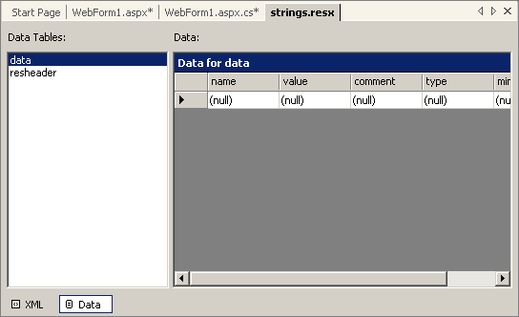
Figure 15-6. A new resource file
To enter translated strings for the Web form’s user interface into a resource file, follow these steps:
- Type an identifier for the Web form element in the Name field of the resource file. The identifier must be unique within the scope of the application, so a convention such as formname.elementname works well—for example, webform1.butOK.
- Type the translated string for that element in the Value field of the resource file.
Figure 15-7 shows translated strings entered for the server control and HTML elements created in the preceding section.
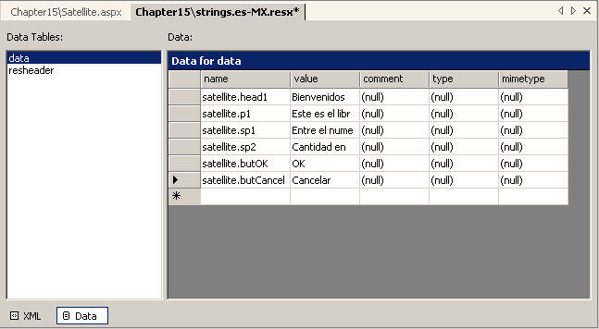
Figure 15-7. Translated strings in a resource file
TIP
The Name field within a resource file is case sensitive by default. To avoid errors locating resources at run time, use a consistent capitalization scheme when naming resource elements.
Loading Resource Files
The .NET Framework provides resource management as part of the System.Resources namespace. To use classes from that namespace without fully qualifying their names, include an Imports/using statement at the beginning of your Web form, as shown here:
Visual Basic .NET
Imports System.Resources
Visual C#
using System.Resources;
To load resources into a Web form, create an instance of the ResourceManager class. For example, the following line loads the resource file for the Web application:
Visual Basic .NET
' Load resources.
Protected gStrings As New ResourceManager("MCSDWebAppsVB.strings", _
GetType(Satellite).Assembly)
Visual C#
// Load resources.
protected ResourceManager gStrings = new
ResourceManager("MCSDWebAppsCS.strings", typeof(Satellite).Assembly);
The preceding example loads the resources stored in the Strings assembly file associated with the Satellite Web form’s parent assembly and stores the returned object in the gStrings variable. The arguments for the ResourceManager class’s constructor are described in Table 15-3.
Table 15-3. ResourceManager Arguments
Argument | Description
baseName | The namespace of the resource within the project. For Visual Basic .NET projects, this is projectname.resourcebasename. For Visual C# projects, this is rootnamespace.resourcebasename. The resourcebasename part omits culture codes, so MyProj.strings includes Strings.resx, Strings.en.resx, Strings.es.rex, and so on.
assembly | The object representing the current executable assembly. Use the Type class’s Assembly property to get the value to pass to this argument—for example, GetType(“Webform1”).Assembly.
Getting and Setting User-Interface Culture
As shown in Lesson 1, you get the user’s culture from the Request object’s UserLanguages array, and you set the current thread’s culture using the Thread class’s CurrentCulture property. When working with satellite assemblies, you need to add one more step: setting the CurrentUICulture property. This property specifies which satellite assembly is used when loading strings from the ResourceManager object.
To set the current user-interface culture for a thread, set the Thread object’s CurrentUICulture property. For example, the following code gets the user’s preferred language and then sets both the culture and user-interface culture for the current thread:
Visual Basic .NET
Private Sub Page_Load(ByVal sender As System.Object, _
ByVal e As System.EventArgs) Handles MyBase.Load
If Not IsPostBack Then
' Get the user's perferred language.
Dim sLang As String = Request.UserLanguages(0)
' Set the thread's culture for formatting, comparisons, etc.
Thread.CurrentThread.CurrentCulture = _
CultureInfo.CreateSpecificCulture(slang)
' Set the thread's UICulture to load resources
' from satellite assembly.
Thread.CurrentThread.CurrentUICulture = New CultureInfo(slang)
End If
End Sub
Visual C#
private void Page_Load(object sender, System.EventArgs e)
{
if (!IsPostBack)
{
// Get the user's perferred language.
string sLang = Request.UserLanguages[0];
// Set the thread's culture for formatting, comparisons, etc.
Thread.CurrentThread.CurrentCulture =
CultureInfo.CreateSpecificCulture(sLang);
// Set the thread's UICulture to load resources
// from satellite assembly.
Thread.CurrentThread.CurrentUICulture = new CultureInfo(sLang);
}
}
In the preceding code, the CurrentCulture and CurrentUICulture properties are set differently. CurrentCulture uses the CreateSpecificCulture method to ensure that the returned object is not a neutral culture. Neutral cultures represent general languages rather than a specific language and region. The CurrentCulture property can’t be set to a neutral culture because it uses region information to format currencies, among other things.
When you have set the thread’s CurrentUICulture, ASP.NET automatically selects the resources that match, in the following order:
- If a satellite assembly is found with an exactly matching culture, the resources from that assembly are used.
- If a satellite assembly is found with a neutral culture that matches the CurrentUICulture, resources from that assembly are used.
- If a match is not found for the CurrentUICulture, the fallback resources stored in the executable assembly are used.
Displaying Resource Strings
After you have completed all of the preceding tasks, displaying strings from a resource file on the Web form is straightforward.
To display strings from the resource file on a Web form, use the ResourceManager object’s GetString method to retrieve strings and assign them to the Text, value, or innerHTML properties of the Web form’s elements.
The following code brings the preceding steps together to load a resource file, get the user’s culture, set the current thread’s culture, and display strings from the resource file in the Web form server control and HTML elements:
Visual Basic .NET
Imports System.Resources
Imports System.Globalization
Imports System.Threading

' Load resources.
Protected gStrings As New ResourceManager("MCSDWebAppsVB.strings", _
GetType(Satellite).Assembly)

Private Sub Page_Load(ByVal sender As System.Object, _
ByVal e As System.EventArgs) Handles MyBase.Load
If Not IsPostBack Then
' Get the user's preferred language.
Dim sLang As String = Request.UserLanguages(0)
' Set the thread's culture for formatting, comparisons, etc.
Thread.CurrentThread.CurrentCulture = _
CultureInfo.CreateSpecificCulture(sLang)
' Set the thread's UICulture to load resources from
' satellite assembly.
Thread.CurrentThread.CurrentUICulture = New CultureInfo(sLang)
' Get strings from resource file.
head1.InnerHtml = gStrings.GetString("satellite.head1")
p1.InnerHtml = gStrings.GetString("satellite.p1")
sp1.InnerHtml = gStrings.GetString("satellite.sp1")
sp2.InnerHtml = gStrings.GetString("satellite.sp2")
butOK.Text = gStrings.GetString("satellite.butOK")
butCancel.Value = gStrings.GetString("satellite.butCancel")
End If
End Sub
Visual C#
using System.Globalization;
using System.Threading;
using System.Resources;

// Load resources.
protected ResourceManager gStrings = new ResourceManager
"MCSDWebAppsCS.strings",
typeof(Satellite).Assembly);

private void Page_Load(object sender, System.EventArgs e)
{
if (!IsPostBack)
{
// Get the user's perferred language.
string sLang = Request.UserLanguages[0];
// Set the thread's culture for formatting, comparisons, etc.
Thread.CurrentThread.CurrentCulture =
CultureInfo.CreateSpecificCulture(sLang);
// Set the thread's UICulture to load resources
// from satellite assembly.
Thread.CurrentThread.CurrentUICulture = new CultureInfo(sLang);
// Get strings from resource file.
head1.InnerHtml = gStrings.GetString("satellite.head1");
p1.InnerHtml = gStrings.GetString("satellite.p1");
sp1.InnerHtml = gStrings.GetString("satellite.sp1");
sp2.InnerHtml = gStrings.GetString("satellite.sp2");
butOK.Text = gStrings.GetString("satellite.butOK");
butCancel.Value = gStrings.GetString("satellite.butCancel");
}
}
At run time, the preceding code displays the translated strings from the resource files based on the user’s preferred language, as shown in Figure 15-8.
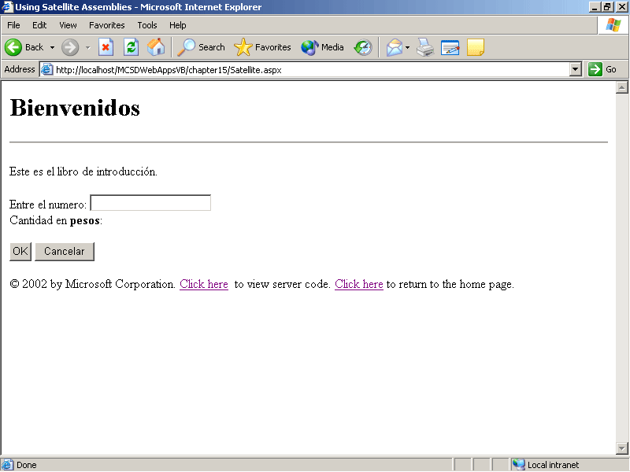
Figure 15-8. Displaying strings from a resource file
Lesson 3: Globalization Issues
The .NET Framework handles many globalization issues automatically, based on the setting in the CurrentCulture property. However, globalization issues also affect some basic programming techniques. In this lesson, you’ll learn about some general programming issues you need to think about when developing global applications. You’ll also learn about issues that arise when storing and presenting the extended character sets used by some languages.
After this lesson, you will be able to
- Discuss some of the general programming issues affected by globalization
- Save Web forms containing special characters from other languages
- Use Web forms stored in different character encodings
- Detect the user’s requested character encoding
- Create responses using different character encodings
Estimated lesson time: 10 minutes
General Programming Issues
The “Best Practices for Developing World-Ready Applications” topic in the Visual Studio .NET online Help provides a helpful list of items that you should consider when developing Web applications that will be translated into different languages. The following sections provide more detail on points from that topic that are relevant to Web applications.
Sorting and Comparing Strings
Sorting and string comparison you perform using the .NET Framework classes give the correct result based on the current culture. You need to worry about globalization issues only when implementing your own techniques for those tasks, such as when you are implementing custom sorting procedures. In those cases, use the System.Globalization namespace’s CompareInfo class to perform culturally aware string comparisons.
Custom Validation Controls
ASP.NET server controls acquire specific properties based on the current culture. This includes the validation controls. You do need to consider globalization issues when creating custom validation controls, however.
For example, if you are writing a custom validation procedure that verifies that input is numeric, don’t rely on the numeric value of the input characters. Instead, use a culturally aware test such as using the Convert class within an exception-handling structure to test whether the value is numeric.
Building Strings
Because some languages read from right to left, and because some words change meaning when in proximity to other words, it’s difficult to build strings using concatenation in a way that works for all cultures. Instead, you store completed strings in a resource file and retrieve the strings as needed by using the Resource Manager.
Getting Substrings
In some languages, character symbols (called glyphs) are composed of two characters. In those cases, you might need to adjust how you get substrings. For example, getting the first character of a user’s response would be meaningless in those cases.
Character Encoding
Characters within strings can be represented many different ways within a computer. These different ways of representing characters are called character encodings because they encode characters into numbers that the computer can understand.
The common language runtime (CLR) uses the UTF-16 character encoding, which maps characters to 16-bit numbers. These 16-bit numbers provide enough room to accommodate the characters for almost all written languages. Unfortunately, that’s about double the size that other character encoding schemes use, which makes the UTF-16 character encoding less than optimal for transmitting text over the Internet.
Therefore, ASP.NET uses the UTF-8 character encoding by default when interpreting requests and composing responses. UTF-8 is optimized for the lower 127 ASCII characters, which means it provides an efficient way to encode languages that use the Latin alphabet. UTF-8 is also backward-compatible with the ASCII character encoding, meaning that UTF- 8 readers can interpret ASCII files.
The CLR handles the conversion between encodings by using classes from the System.Text namespace. You usually don’t need to be aware that any of this is going on, with the following exceptions:
- If you go to save a Web form or an HTML file that includes extended characters from the UTF-8 encoding
- If you need to support specific encodings other than UTF-8
Saving Encoded Files
When you create a Web form that contains characters other than the first 127 ASCII characters, Visual Studio .NET prompts you to save the file using encoding, as shown in Figure 15-9.
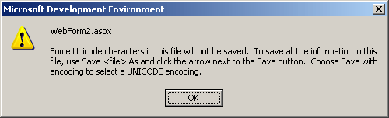
Figure 15-9. Saving files with character encoding
To save a file with encodings, follow these steps:
- From the File menu, choose Save As, click the Save drop-down arrow, and then select Save With Encoding. Visual Studio .NET displays the Advanced Save Options dialog box, as shown in Figure 15-10.
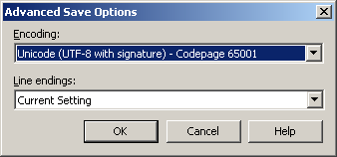
Figure 15-10. Specifying encoding while saving a file
- Choose the encoding you want use for saving the file. Click OK.
Saving the file using the UTF-8 character encoding with signature allows ASP.NET to automatically detect the encoding of the file. If you don’t choose to include the signature, or if you use another encoding, you must specify the fileEncoding attribute in the Web.config file, as shown here:
<globalization requestEncoding="utf-8" responseEncoding="utf-8"
fileEncoding="utf-8" />
Using Other Encodings
By default, Web applications interpret requests and compose responses using the UTF-8 character encoding. These defaults are set in the globalization element of the Web.config file, as shown in the preceding section.
If a Web application receives a request for an encoding other than UTF-8, ASP.NET interprets that request using the request’s encoding. However, ASP.NET does not automatically generate the response in that encoding.
To detect when a request has a specific encoding, get the Request object’s ContentEncoding property. For example, the following code displays the encoding of a request on a Web form:
Visual Basic .NET
Response.Write(Request.ContentEncoding.WebName)
Visual C#
Response.Write(Request.ContentEncoding.WebName);
To specify a specific encoding for a response, set the Response object’s ContentEncoding property using the System.Text namespace’s Encoding class, or use the value returned from the Request object’s ContentEncoding property. For example, the following code creates a response using the shift_JIS character encoding:
Visual Basic .NET
Imports System.Text
Private Sub Page_Load(ByVal sender As System.Object, _
ByVal e As System.EventArgs) Handles MyBase.Load
Response.ContentEncoding = Encoding.GetEncoding("shift_JIS")
Response.Write("This response uses the character encoding: ")
Response.Write(Response.ContentEncoding.WebName)
End Sub
Visual C#
using System.Text;
private void Page_Load(object sender, System.EventArgs e)
{
Response.ContentEncoding = Encoding.GetEncoding("shift_JIS");
Response.Write("This response uses the character encoding: ");
Response.Write(Response.ContentEncoding.WebName);
}
For more information about character encoding, see the following online Help topics:
- “Unicode in the .NET Framework”
- “Encoding Base Types”
- “System.Text Namespace”
You can also find information about character encoding on the following Web sites:
- http://www.unicode.org
- http://www.w3.org/TR/REC-html40/charset.html
Summary
- Use the Request object’s UserLanguages array to detect the user’s culture.
- Set the culture and uiCulture attributes of the globalization element in Web.config to create culture-specific Web applications.
- The .NET Framework identifies cultures using the language and region codes listed in the “CultureInfo Class” online Help topic.
- Set the culture used by the application for formatting dates, currencies, numbers, and determining sort order using the Thread class’s CurrentCulture property.
- Use the Thread class’s CurrentUICulture to determine which satellite assembly is used to load localized resources.
- Add id and runat attributes to HTML elements to be able to display localized strings from resource files in those elements at run time.
- Elements within a resource file are case sensitive and must be uniquely named within the scope of the application, so use a naming convention such as webform.id.
- When creating Web forms that use non-ASCII characters, save the file using the UTF-8 character encoding with a signature. Including the signature allows ASP.NET to automatically detect the file’s encoding.
Lab: Creating a Currency Converter
In this lab, you’ll create a simple currency converter Web application that uses the user’s culture to determine the type of conversion to perform:
- An unrecognized culture converts euros to dollars and pesos, and displays text in English as the fallback interface.
- An English-US culture converts dollars to euros and pesos and displays an English-language interface.
- A Spanish-Mexican culture converts pesos to dollars and euros and displays a Spanish-language interface.
When complete, the Web application will appear as shown in Figure 15-11.
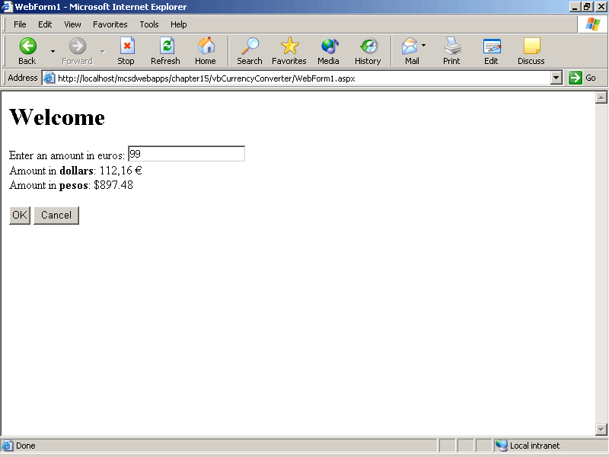
Figure 15-11. Currency converter (fallback interface)
Estimated lesson time: 20 minutes
Exercise 1: Create the Currency Converter Web Form

The currency converter Web application contains a single Web form that receives input from a text box and displays output in two labels when the user clicks OK. The Web form also includes a Cancel HTML button that clears the text box.
Because the application will be localized, the HTML elements on the Web form must have id and runat attributes so that the localized resource strings can be loaded into those controls from server-side code.
To create the Currency Converter Web form
- Create a new Web form named Converter.
- Switch to HTML view, and enter the following HTML between the <form> and </ form> tags of the Web form:
- <h1 id="head1" runat="server">Head1</h1>
- <span id="sp1" runat="server">Enter an amount: </span>
- <asp:TextBox ID="txtCurrency" Runat="server" />
- <br>
- <span id="sp2" runat="server">Amount in: </span>
- <asp:Label ID="lblCurrency1" Runat="server" />
- <br>
- <span id="sp3" runat="server">Amount in: </span>
- <asp:Label ID="lblCurrency2" Runat="server" />
- <br><br>
- <asp:Button ID="butOK" Text="OK" Runat="server" />
- <input id="butCancel" runat="server" type="button"
onclick="txtCurrency.Text=''" value="Cancel">
- When you have finished, switch the Web form back to Design view. This is an important step because it generates the correct control declarations in the code file.
Exercise 2: Create the User-Interface Resource Files
The Web form created in the preceding exercise contains only dummy entries for the text that will actually be displayed in the user interface. For instance, the Web form’s heading is “Head1.” In this exercise, you’ll create the strings that are displayed in place of those dummy entries at run time.
To create the user-interface resource files
- From the Project menu, choose Add New Item, and then select Assembly Resource File from the list of templates. Name the resource file strings.resx.
- Add the entries shown in Figure 15-12 to the resource file to create the fallback values for the user interface.
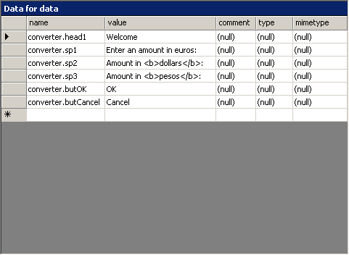
Figure 15-12. Fallback values for the user interface
- Create a new resource file named strings.en-US.resx, and add the entries shown in Figure 15-13 to create the interface for users with the English-US culture:
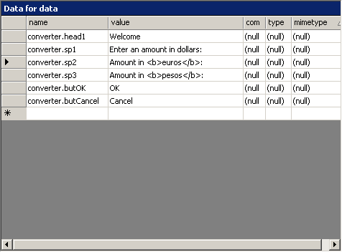
Figure 15-13. English-US culture values
- Create another new resource file named strings.es-MX.resx, and add the entries shown in Figure 15-14 for the Spanish-Mexican culture:
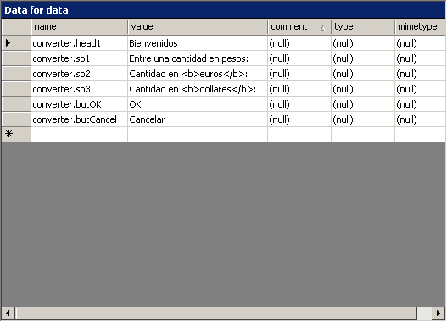
Figure 15-14. Spanish-Mexican culture values
- When you have finished, click Save All to save your work.
You can create additional resource files for other cultures if you want. Just include the culture code in the resource file name, as shown in the preceding steps. Visual Studio .NET will automatically compile the resources as satellite assemblies and store them in the appropriate subfolder when you build the application.
Exercise 3: Load Resources Based on User Culture
In this exercise, you’ll detect the user’s culture, load resources, and display the resources matching the user’s culture.
To load resources based on the user’s culture
- Add the following Imports or using statements to the beginning of the Web form’s code file:
Visual Basic .NET
Imports System.Resources
Imports System.Globalization
Imports System.Threading
Visual C#
using System.Resources;
using System.Globalization;
using System.Threading;
- Add the following code at the class level of the Web form to load the resources into the ResourceManager object. Replace the projectName placeholder in the following code with the name of your application’s root namespace.
Visual Basic .NET
Protected gStrings As New ResourceManager("projectName.strings", _
GetType(Converter).Assembly)
Visual C#
protected ResourceManager gStrings = new
ResourceManager("projectName.strings", typeof(Converter).Assembly);
- Add the following code to the Page_Load event procedure to detect the user’s culture, set the application thread’s user interface culture to match, and display the localized resource strings in the user interface:
Visual Basic .NET
Private Sub Page_Load(ByVal sender As System.Object, _
ByVal e As System.EventArgs) Handles MyBase.Load
If Not IsPostBack Then
' Get the user's preferred language.
Dim sLang As String = Request.UserLanguages(0)
' Set the thread's UICulture to load resources.
Thread.CurrentThread.CurrentUICulture = New CultureInfo(sLang)
' Set the thread's culture for date/string/currency formats.
Thread.CurrentThread.CurrentCulture = _
CultureInfo.CreateSpecificCulture(sLang)
' Get strings from resource file.
head1.InnerHtml = gStrings.GetString("converter.head1")
sp1.InnerHtml = gStrings.GetString("converter.sp1")
sp2.InnerHtml = gStrings.GetString("converter.sp2")
sp3.InnerHtml = gStrings.GetString("converter.sp3")
butOK.Text = gStrings.GetString("converter.butOK")
butCancel.Value = gStrings.GetString("converter.butCancel")
End If
End Sub
Visual C#
private void Page_Load(object sender, System.EventArgs e)
{
if (!IsPostBack)
{
// Get the user's preferred language.
string sLang = Request.UserLanguages[0];
// Set the thread's UICulture to load resources
//from satellite assembly.
Thread.CurrentThread.CurrentUICulture = new CultureInfo(sLang);
// Set the thread's culture for date/string/currency formats.
Thread.CurrentThread.CurrentCulture =
CultureInfo.CreateSpecificCulture(sLang);
// Get strings from resource file.
head1.InnerHtml = gStrings.GetString("converter.head1");
sp1.InnerHtml = gStrings.GetString("converter.sp1");
sp2.InnerHtml = gStrings.GetString("v.sp2");
sp3.InnerHtml = gStrings.GetString("v.sp3");
butOK.Text = gStrings.GetString("v.butOK");
butCancel.Value = gStrings.GetString("v.butCancel");
}
}
You have to load the localized user-interface strings only the first time the page is displayed, as shown in the preceding code. ASP.NET retains the value of the controls between page displays automatically.
Exercise 4: Perform Culture-Dependent Conversion
Just as the currency converter application displays a different interface for different cultures, it also performs different conversions based on the current culture. In this exercise, you’ll write the code that performs the culture-dependent conversions.
To perform the culture-dependent conversions
Add the following code to the butOK_Click event procedure to detect the current culture and perform different conversions based on that information:
Visual Basic .NET
Private Sub butOK_Click(ByVal sender As System.Object, _
ByVal e As System.EventArgs) Handles butOK.Click
' Get the amount.
Dim SrcAmount As Double = Convert.ToDouble(txtCurrency.Text)
Dim DestAmount As Double
' Culture variables for currency formatting.
Dim Europe As New CultureInfo("fr-FR")
Dim USA As New CultureInfo("en-US")
Dim Mexico As New CultureInfo("es-MX")
' Perform conversions based on current user-interface culture.
Select Case Thread.CurrentThread.CurrentCulture.Name
Case "en-US"
' Convert from dollars.
DestAmount = SrcAmount * 1.1329
lblCurrency1.Text = DestAmount.ToString("C", Europe)
DestAmount = SrcAmount * 9.0655
lblCurrency2.Text = DestAmount.ToString("C", Mexico)
Case "es-MX"
' Convert from pesos.
DestAmount = SrcAmount * 0.125
lblCurrency1.Text = DestAmount.ToString("C", Europe)
DestAmount = SrcAmount * 0.1103
lblCurrency2.Text = DestAmount.ToString("C", USA)
Case Else
' Convert from euros.
DestAmount = SrcAmount * 8.0021
lblCurrency1.Text = DestAmount.ToString("C", USA)
DestAmount = SrcAmount * 0.1103
lblCurrency2.Text = DestAmount.ToString("C", Mexico)
End Select
End Sub
Visual C#
private void butOK_Click(object sender, System.EventArgs e)
{
// Get the amount.
double SrcAmount = Convert.ToDouble(txtCurrency.Text);
double DestAmount;
// Culture variables for currency formatting.
CultureInfo Europe = new CultureInfo("fr-FR");
CultureInfo USA = new CultureInfo("en-US");
CultureInfo Mexico = new CultureInfo("es-MX");
// Perform conversions based on current user-interface culture.
switch (Thread.CurrentThread.CurrentCulture.Name)
{
case "en-US":
// Convert from dollars.
DestAmount = SrcAmount * 1.1329;
lblCurrency1.Text = DestAmount.ToString("C", Europe);
DestAmount = SrcAmount * 9.0655;
lblCurrency2.Text = DestAmount.ToString("C", Mexico);
break;
case "es-MX":
// Convert from pesos.
DestAmount = SrcAmount * 0.125;
lblCurrency1.Text = DestAmount.ToString("C", Europe);
DestAmount = SrcAmount * 0.1103;
lblCurrency2.Text = DestAmount.ToString("C", USA);
break;
default:
// Convert from euros.
DestAmount = SrcAmount * 8.0021;
lblCurrency1.Text = DestAmount.ToString("C", USA);
DestAmount = SrcAmount * 0.1103;
lblCurrency2.Text = DestAmount.ToString("C", Mexico);
break;
}
}
The preceding code creates CultureInfo objects (Europe, United States, and Mexico) for each cultural conversion. These objects provide the appropriate currency formatting in the ToString methods. The Europe object uses the culture code for France, because France uses the euro as currency. There isn’t a culture code for the European Union.
The preceding example also hard-codes the exchange rates into the procedure. You wouldn’t do that in a real-world situation, of course. Getting current exchange rates is an appropriate task for Web Services. See Chapter 7, “Advanced Web Forms Programming,” for a lesson on how to use XML Web Services.
Review
The following questions are intended to reinforce key information presented in this chapter. If you are unable to answer a question, review the appropriate lesson and then try the question again. Answers to the questions can be found in the appendix.
- What is the difference between the CurrentCulture property and the CurrentUICulture property?
- How do you detect the user’s culture?
- What is a neutral culture?
- How does character encoding affect file formats?
Appendix A
Questions and Answers
Chapter 1: Introduction to Web Programming
- Give two examples of how an ASP.NET Web application is different from a traditional Windows application.
Web applications and traditional Windows applications have the following differences:
Feature | ASP.NET Web application | Unmanaged Windows application
Architecture | Client/server | Local user
Execution | Runs under common language runtime using managed code | Runs under Windows using unmanaged code
- What are the two main parts of the .NET Framework?
The common language runtime (CLR).
The .NET Framework class library.
- How do you restore the default window settings in Visual Studio .NET?
From the Tools menu, choose Options, and then click Reset Window Layout.
- Why doesn’t the Visual Studio .NET Code Editor automatically complete the following partial line of code (Visual C# users only)?
int intX = system.math
The namespace System.Math must be capitalized in Visual C# for IntelliSense to recognize the namespace.
- When can’t you use ASP.NET to create a Web application?
When you are developing for non–Microsoft Windows Web servers, such as Linux/Apache.
Chapter 2: Creating Web Forms Applications
- Explain where Visual Studio .NET stores Web application projects.
Web application projects are stored in a new virtual folder for each project. The properties of that virtual folder determine where the files are physically stored. These properties can be viewed in IIS.
- List the four major differences between Web and Windows applications.
  - Web forms cannot use the standard Windows controls. Instead, they use server controls, HTML controls, user controls, or custom controls created specially for Web forms.
  - Web applications are displayed in a browser. Windows applications display their own windows and have more control over how those windows are displayed.
  - Web forms are instantiated on the server, sent to the browser, and destroyed immediately. Windows forms are instantiated, exist for as long as needed, and are destroyed.
  - Web applications run on a server and are displayed remotely on clients. Windows applications run on the same machine they are displayed on.
- Describe the life cycle of a Web application: When are Web forms instantiated and how long do they exist?
A Web application starts with the first request for a resource within the application’s boundaries. Web forms are instantiated when they are requested. They are processed by the server and are abandoned immediately after the server sends its response to the client. A Web application ends after all client sessions end.
- How do you preserve persistent data, such as simple variables, in a Web application?
You can preserve data in state variables, such as ApplicationState, SessionState, or ViewState.
- What determines the boundaries of a Web application?
IIS determines Web application boundaries by the structure of the application’s virtual folders. A Web application boundary starts in the folder containing the start page of the application, and it ends at the last subordinate folder or when it encounters another start page in a subordinate folder.
Chapter 3: Working with Web Objects
- How does the .NET Framework organize its classes?
The .NET Framework uses namespaces to organize its classes.
- In Visual Basic .NET, what is the difference between a class module and a code module?
Class modules are instantiated at run time to create objects that provide separate storage for variables and properties in each instance. Code modules do not have instances, so any module-level variables they use are shared among calls to the module’s procedures.
- In Visual C#, how do you declare a method to make it available without having to first instantiate an object from the class?
To create a method that can be called without instantiating an object, declare that method as static.
- How do you call a member of a base class from within a derived class?
To refer to a member of a base class in Visual Basic .NET, use the MyBase keyword. To refer to a member of a base class in Visual C#, use the base keyword.
- Where would you save the following data items so that they persist between requests to a Web form?
  - A control created at run time
  - An object that provides services to all users
  - User preferences
Save controls created at run time in the Page object’s ViewState.
Save objects that provide services to all users in the Application state.
Save user preferences in SessionState.
Chapter 4: Creating a User Interface
- What is the main difference between the Button server control and the Button HTML control?
When clicked, the Button server control triggers an ASP.NET Click event procedure on the server. The Button HTML control triggers the event procedure indicated in the button’s onclick attribute, which runs on the client.
- How do you get several RadioButton controls to interoperate on a Web form so that only one of the RadioButton controls can have a value of True/true at any given time?
Set the GroupName property of each RadioButton to the same name.
- Why does ASP.NET perform validation on both the client and the server?
Client-side validation helps avoid round-trips to the server. Validating on the client ensures that the data is valid before it is submitted, in most cases. However, because validation might be turned off (or maliciously hacked) on the client, data must be revalidated on the server side. This provides full assurance that the data is valid while avoiding as many round-trips as possible.
- What types of validation would you use to verify that a user entered a valid customer number?
You would use a RequiredFieldValidator and a RegularExpressionValidator. If you have access to a list of expected customer numbers, you could replace the RegularExpressionValidator with a CustomValidator that checked the list.
- What is wrong with the following line of code?
Visual Basic .NET
Server.Transfer("Default.htm")
Visual C#
Server.Transfer("Default.htm");
You can’t use the Transfer method with HTML pages. It works only with .aspx pages.
- Why can’t you open a new browser window from within server code?
Server code executes on the server, whereas the new window is created on the client. You need to use client-side code to do things that affect the client, such as upload files, display new windows, or navigate back in history.
Chapter 5: Storing and Retrieving Data with ADO.NET
- What steps would you follow and what objects would you use to quickly find the number of records in a database table?
There are two ways to accomplish this task:
  - Use a database connection and a command object to execute a SQL command that re-turns the number of rows in the table.
  - Use a database connection and data adapter object to create a data set for the table, and then get the number rows in the data set.
- How do typed data sets differ from untyped data sets, and what are the advantages of typed data sets?
Typed data sets use explicit names and data types for their members, whereas untyped data sets use collections to refer to their members. The following examples show a typed reference vs. an untyped reference to a data item:
Visual Basic .NET
' Typed reference to the Contacts table's HomePhone column.
DataSet1.Contacts.HomePhoneColumn.Caption = "@Home"
' Untyped reference to the Contacts table's HomePhone column.
DataSet1.Tables("Contacts").Columns("HomePhone").Caption = "@Home"
Visual C#
// Typed reference to the Contacts table's HomePhone column.
DataSet1.Contacts.HomePhoneColumn.Caption = "@Home";
// Untyped reference to the Contacts table's HomePhone column.
DataSet1.Tables["Contacts"].Columns["HomePhone"].Caption = "@Home";
Typed data sets do error checking at design time. This error checking helps catch typos and type mismatch errors, which would be detected only at run time with untyped data sets.
- How do you call a stored procedure?
Create a command object, set the object’s CommandText property to the name of the stored procedure, and set the CommandType property to StoredProcedure. To execute the stored procedure, use the command object’s ExecuteNonQuery, ExcecuteScalar, ExecuteReader, or ExecutelXmlReader method. For example, the following code calls the Ten Most Expensive Products stored procedure on the Northwind Traders database:
Visual Basic .NET
' Create a command object to execute.
Dim cmdTopTen As New SqlCommand(connNWind)
' Set command text.
cmdTopTen.CommandText = "Ten Most Expensive Products"
' Set the command properties.
cmdTopTen.CommandType = CommandType.StoredProcedure
' Create a data reader object to get the results.
Dim drdTopTen As SqlDataReader
' Open the connection.
connNWind.Open()
' Excecute the stored procedure.
drdTopTen = cmdTopTen.ExecuteReader()
Visual C#
// Create a connection for NorthWind Trader's database.
SqlConnection connNWind = new SqlConnection("integrated security=SSPI;" +
"data source=(local);initial catalog=Northwind");
// Create a command object to execute.
SqlCommand cmdTopTen = new SqlCommand(connNWind);
cmdTopTen.CommandText = "Ten Most Expensive Products";
// Set the command properties.
cmdTopTen.CommandType = CommandType.StoredProcedure;
// Create a data reader object to get the results.
SqlDataReader drdTopTen;
// Open the connection.
connNWind.Open();
// Excecute the stored procedure.
drdTopTen = cmdTopTen.ExecuteReader();
- Explain the difference between handling transactions at the data set level and at the database level.
Data sets provide implicit transactions, because changes to the data set aren’t made permanent in the database until you call the Update method. To handle transactions in a data set, process the Update method and check for errors. If errors occur during an update, none of the changes from the data set is made in the database. You can try to correct the error and resubmit the update, or you can roll back the changes to the data set using the RejectChanges method.
Databases provide explicit transactions through the Transaction object. You create a Transaction object from a database connection and then assign that Transaction object to the commands you want to include in the transaction through the command object’s Transaction property. As you perform the commands on the database, you check for errors. If errors occur, you can either try to correct them and resubmit the command, or you can restore the state of the database using the Transaction object’s RollBack method. If no errors occur, you can make the changes permanent by calling the transaction object’s Commit method.
Chapter 6: Catching and Correcting Errors
- Explain why exception handling is important to a completed application.
When an unhandled exception occurs in an application, the application stops—the user can’t proceed, and any work he or she did immediately prior to the exception is lost. Exception handling provides a way to intercept and correct unusual occurrences that would otherwise cause these problems.
- List two different exception-handling approaches in ASP.NET Web applications.
Exceptions can be handled in exception-handling blocks using the Try, Catch, and Finally keywords in Visual Basic .NET or the try, catch, and finally keywords in Visual C#. They can also be handled using Error event procedures at the Global, Application, or Page levels using the Server object’s GetLastError and ClearError methods.
- Describe the purpose of error pages and why they are needed.
Because Web applications run over the Internet, some exceptions occur outside the scope of the application. This means that your application can’t respond directly to these exceptions. These types of exceptions are identified by HTTP response codes, which IIS can respond to by displaying custom error pages listed in your application’s Web.config file.
- Explain why tracing helps with exception handling.
Tracing allows you to record unusual events while your application is running, without users being aware of it. If an unanticipated exception occurs, your application can write a message to the trace log, which helps you diagnose problems during testing and after deployment.
Chapter 7: Advanced Web Forms Programming
- Write the HTML for a hyperlink that will send mail when the user clicks the link.
<a href="mailto:you@microsoft.com?SUBJECT=Sending from a client&BODY=Some message text.">Send mail</a>
- Write the code that creates a cookie containing the user name Rob Young and the current date to the user’s computer. Set the cookie to remain on the user’s computer for 30 days.
Visual Basic .NET
Dim cookUserInfo As New HttpCookie("UserInfo")
cookUserInfo("Name") = "Rob Young"
cookUserInfo("Time") = DateTime.Now.ToString()
cookUserInfo.Expires = DateTime.Now.AddDays(30)
Response.Cookies.Add(cookUserInfo)
Visual C#
HttpCookie cookUserInfo = new HttpCookie("UserInfo")
CookUserInfo["Name"] = "Rob Young"
CookUserInfo["Time"] = DateTime.Now.ToString()
cookUserInfo.Expires = DateTime.Now.AddDays(30)
Response.Cookies.Add(cookUserInfo)
- What attribute do you use to hide a public .NET class from COM?
Use the ComVisible attribute to select which public .NET classes and members are visible to COM. This attribute applies hierarchically for the assembly, class, and member levels.
- Why can’t you open a new browser window using server-side code? How would you display a page in a new window with a client-side script?
Server-side code can execute tasks only on the server. To perform a task on the client’s computer, such as opening a new browser window, the code needs to run on the client.
You can open a new window using the DOM window object. For example, the following HTML Button control opens a Help page in a new window:
<button id="butHelp" onclick="window.open('help.aspx', 'help', 'height=200,width=300')">Help</ button>
- How do you declare an unmanaged procedure within .NET?
Use the DllImport attribute or a Visual Basic .NET Declare statement to declare an unmanaged procedure for use with a .NET assembly. The DllImport attribute is found in the System.Runtime.InteropServices namespace.
Chapter 8: Maintaining Security
- Which ASP.NET authentication mode is best suited to identifying and authorizing users who belong to a corporate network?
Windows authentication is best suited to authenticating users of a corporate network because it uses the accounts and permissions that already exist for network users.
- What is the difference between Windows and Forms authentication user lists in Web.config?
User lists for Windows authentication are included in the <authorization> element of Web.config.
User lists for Forms authentications are included in the <credentials> element of Web.config or as part of an external users database or file.
- How do you require authentication using the Web.config file? (The answer is the same for all ASP.NET authentication modes.)
Include the following <authorization> element to require authentication:
<authorization>
<deny users="?" />
</authorization>
- How do you run a Web application using the permission set of an authenticated user?
Use the identity element in Web.config to execute code using the authenticated user’s account. For example:
<!-- Impersonate the authenticated user -->
<identity impersonate="true" />
- How does the Secure Sockets Layer (SSL) provide security in a Web application?
SSL protects data exchanged between a client and a Web application by encrypting the data before it is sent across the Internet.
- How do you begin and end secure communication via SSL?
To begin secure communication, specify https in an address. For example:
<a href="https://www.contoso.com/secure.htm">Secure page.</a>
To end secure communication, specify http. For example:
<a href="http://www.contoso.com/Default.htm">Not secure.</a>
Chapter 9: Building and Deploying Web Applications
- What permissions do Web applications run under by default?
By default, Web applications run as the ASPNET user, which has limited permissions equivalent to the Users group.
- Why is the Machine.config file important to deployed Web applications?
The Machine.config file controls many aspects of how Web applications run, including how processes are recycled, what types of request queue limits are imposed, and what interval is used when checking if users are still connected.
- How do you configure a setup project to install an application over the Web?
To configure a setup project to install an application over the Web, select the Web Bootstrapper option from the setup project’s properties. This setting allows the Windows Installer to be downloaded and installed over the Web.
- How do you distribute shared components as part of an installation program?
Shared components should be included as a merge module within the setup project. Merge modules manage the installation of shared components so that they’re not unnecessarily overwritten and so that they can be safely removed when no longer used. Unlike regular setup projects, merge modules can’t be installed by themselves—they can be installed only as part of an application installation.
- How does deploying to a Web farm or a Web garden affect Session state in a Web application?
Web applications that are deployed to a Web farm or a Web garden need to identify a Session state provider in their Web.config file. This is because a single client’s requests can be directed to different processes over the course of his or her session. The Session state provider allows each different process to access the client’s Session state.
Chapter 10: Testing Web Applications
- How do unit, integration, and regression testing relate to each other?
Unit testing is the foundation that ensures that each piece of code works correctly. Integration testing extends this concept by verifying that pieces work together without errors. Regression tests are made up of the existing unit and integration tests, which are run on a regular schedule to assure that new code did not break previously working code.
- Why is load testing likely to be more important for a Web application than for a stand-alone Windows application?
Because Web applications can be public on the Internet, they can have hundreds, thousands, or even millions of users. Load tests let you simulate the expected demand to locate resource conflicts, performance bottlenecks, and other problems that aren’t apparent in single-user tests.
- What is the difference between the Debug and Trace classes?
Under the default environment settings, code using the Debug class is stripped out of release builds, while code using the Trace class is left in. The classes are otherwise equivalent.
- What are the two special steps you need to take to ensure that a COM component can use a component from a .NET assembly?
To use a .NET component from a COM tool, such as VBScript, you must:
  - Register the .NET assembly in the system registry using RegAsm.exe.
  - Make sure that the COM component can find the .NET assembly, either by placing the .NET assembly in the global assembly cache, by placing the two components in the same folder, or by following the other assembly-probing rules.
Chapter 11: Creating Custom Web Controls
- Briefly describe the best uses for each of the three types of Web controls by completing the following sentences:
  - Create a Web user control when you want to…
  - Create a composite custom control when you want to…
  - Create a rendered custom control when you want to…
Create a Web user control when you want to…
…quickly create a group of controls that can be reused throughout a project to perform some logical unit of work.
Create a composite custom control when you want to…
…combine one or more existing controls into a compiled assembly that can be easily reused in many different projects.
Create a rendered control when you want to…
…build an entirely new control that can be compiled into an assembly for use in multiple projects.
- How is deriving important to creating custom Web controls?
Both composite and rendered custom controls are derived from the WebControl base class. That class provides the methods that you override to create the appearance of the custom control.
- What is the most important method to override when you’re creating a composite custom control?
You override the CreateChildControls method to add existing controls to a composite custom control.
- What is the most important method to override when you’re creating a rendered control?
You override the Render method when creating a rendered custom control.
- How is raising a post-back event in a composite control different from raising a post-back event in a rendered control?
In a composite control, you can use one of the contained controls to raise a post-back event. In a rendered control, you must implement the IPostBackEventHandler interface and write a client-side script to raise a post-back event.
Chapter 12: Optimizing Web Applications with Caching
- Write a directive to cache responses for a Web form for 30 seconds, storing different cache responses based on the value of the lstNames control.
<%@ OutputCache Duration=”30” VaryByParam=”lstNames” %>
- A Web form uses fragment caching to store a frequently used user control. At run time, an Object not found error occurs whenever the page is refreshed. What is a likely cause of the error?
The most likely cause is that the user control is referenced in code after it has been cached. Once cached, a user control’s properties and methods are no longer available.
- How can you detect when application data is about to be removed from the cache?
Use the onRemoveCallback delegate.
- Which ASP.NET performance counter is the best indicator of inefficient caching?
The Turnover Rate performance counter.
Chapter 13: Formatting Web Application Output
- What is the advantage of using CSS rather than in-line styles for formatting a Web application?
Using CSS allows you to maintain formatting separately from the content of your Web forms, so changes are easier to make and consistency is easier to maintain.
- Why would you create a style for a class rather than for an HTML element?
You create style classes when you want to apply the same formatting to different types of elements within an application. For example, you might want to create an emphasis style class that applies the same formatting to any text, control, heading, or image that you want to draw the user’s attention to.
- How do CSS and XSL relate to each other when it comes to formatting a Web application?
CSS and XSL are complementary techniques for formatting. CSS determines the font, color, size, background, and other appearance aspects of HTML elements on a Web page. XSL is used to transform XML files into HTML output. In this way, XSL controls the position and appearance of items based on their content. Used together, XSL performs the high-level tasks of composition and layout while CSS performs the low-level tasks of applying fonts, colors, and other appearance features.
- What are the differences between HTML and XML?
  - HTML uses predefined element names, such as <p> and <br>. In XML, you create your own element names to identify hierarchical nodes of data.
  - XML syntax is much stricter than HTML: elements must always have end-tags, element names are case sensitive, attribute values must always be enclosed in quotation marks, and nested elements must be terminated within their parent elements.
  - XML identifies data conceptually based on the data’s content, rather than based on the type of formatting to apply.
Chapter 14: Providing Help
- Which HTML attribute does the server control’s ToolTip property map to in the HTML rendered by ASP.NET?
The ToolTip property is rendered as the title attribute at run time.
- How does displaying HTML Help using the window object’s showHelp method differ from displaying HTML Help using a browser window?
The showHelp method cannot open compiled HTML Help from a network address; the compiled file must first be downloaded to the user’s machine. You can display HTML Help from a network address within a browser window, provided you use the ms-its: protocol. However, the HTML Help Contents, Index, and Search features are not automatically available from a browser window.
- How do you add index keywords to a Help topic?
Insert an object element in the Help topic using the HTML Help ActiveX control. For example, the following object element adds the “numbers” index keyword:
<Object type="application/x-oleobject"
classid="clsid:1e2a7bd0-dab9-11d0- b93a-00c04fc99f9e">
<param name="Keyword" value="numbers">
</OBJECT>
Chapter 15: Globalizing Web Applications
- What is the difference between the CurrentCulture property and the CurrentUICulture property?
The CurrentCulture property affects how the .NET Framework handles dates, currencies, sorting, and formatting issues. The CurrentUICulture property determines which satellite assembly is used when loading resources.
- How do you detect the user’s culture?
Use the Request object’s UserLanguages array. The value at element 0 corresponds to one of the culture codes used by the CultureInfo class. For example:
SLang = Request.UserLanguages(0)
- What is a neutral culture?
Neutral cultures represent general languages without region-specific differences, such as currency. For example, the “es” culture code represents Spanish.
- How does character encoding affect file formats?
When using non-ASCII characters in a Web form, you must save the file with a specific character encoding, such as UTF-8. ASP.NET can automatically detect UTF-8 file encoding if the file is saved with a signature; otherwise, you need to specify the file encoding used in the fileEncoding attribute of the globalization element in Web.config.

